1.Write C++ program to Check whether a number can be represented as difference of two squares

Given a number N, the task is to check if this number can be represented as the difference of two perfect squares or not.

input: N = 3  
Output: Yes  
Explanation:  
2^2 – 1^1 = 3

#include <bits/stdc++.h>

using namespace std;

bool difSquare(int n)

{

if (n % 4 != 2) {

return true;

}

return false;

}

int main()

{

int n = 3;

if (difSquare(n)) {

cout << "Yes\n";

}

else {

cout << "No\n";

}

return 0;

}

Output: n=3

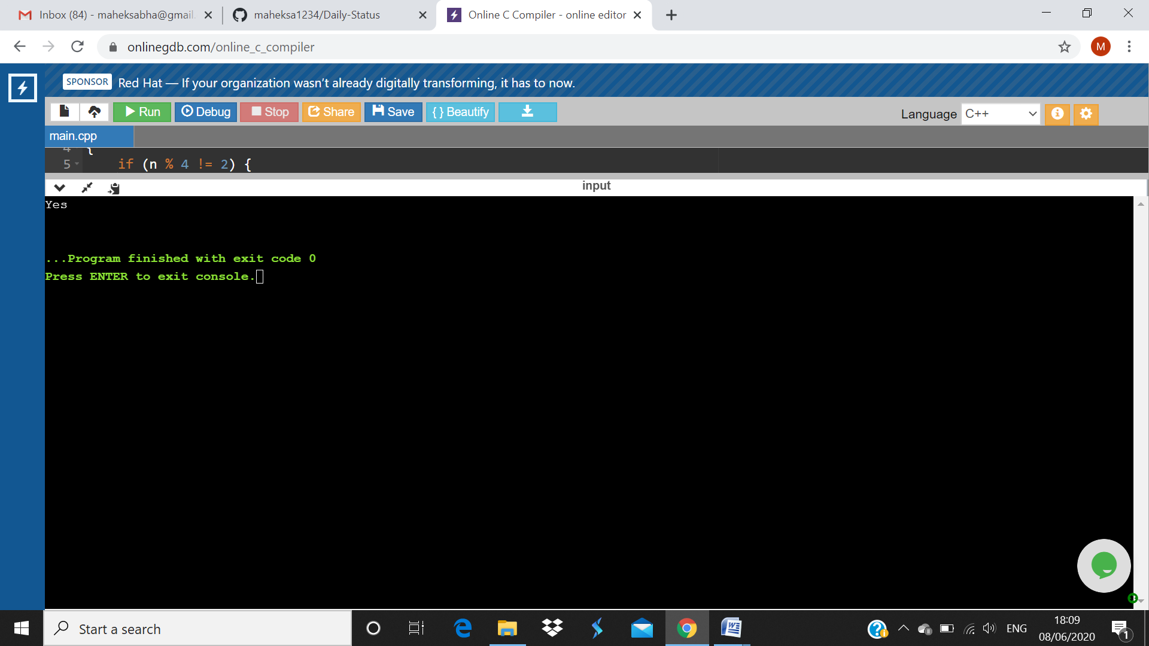

Output: n=6

